**SOFTWARE TESTING ASSIGNMENT MODULE – 1**

1. What is SDLC?

A. SDLC is structure on the imposed of software development product define of planning,implementation,testing,deployment,documentation and maintenance of product.

2. What is software testing?

A. software testing is process used of identify correctness,completeness and quality of developed computer software.

3. What is agile methodology?

A. Agile SDLC is combination of iterative and incremental process model with focus on process adaptability of customer satisfaction by rapid delivery of working software product.

4. What is SRS ?

A.A software requirements specification is a complete description of the system to be developed.

It includes a set of use cases that describe of all the interaction that the users will have with the software.

5. What is oops?

A.Object-oriented programming is a computer programming model that organizes software design around data or object rather than function and logic.An object can be defined as a data field that has

Unique attributes and behavior.

6. Write Basic Concepts of oops

A.Class,object,encapsulation,inheritance,polymorphism,abstraction.

7. What is object ?

A.Is an instances of class.class is variable creation i.e.

8. What is class ?

A.Is an collection of data member(variables) and member function(method,process) with

Its behavior.

9. What is encapsulation ?

A.Wrapping up of data into single unit.Data hiding purpose at a small level.

10. What is inheritance ?

A.Properties of parent class extends into child class.

There are mainly 5 types:

1)Single.

2)Multilevel.

3)Hierarchical.

4)Multiple.

5)Hybrid.

11. What is polymorphism ?

A.Ability to take one name having many forms.

There are 2 types:

1)Compile time (method overloading).

2)Run time (method overriding).

12. Draw Usecase on online bill payment system (paytm)

A.

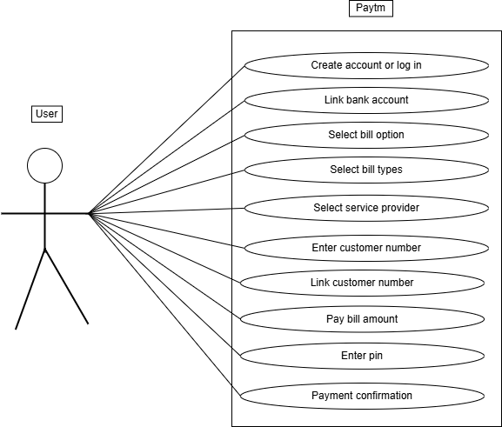

13. Draw Usecase on banking system for customers.

A.

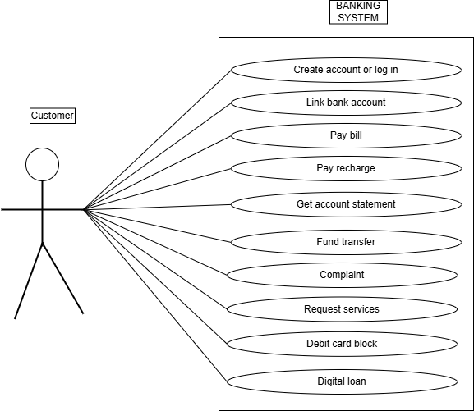

14. Draw Usecase on Broadcasting System.

A.

15. Write SDLC phases with basic introduction

A. 1-Requirement gathering.

▪Collecting and documenting business requirement.

▪Identify project scope,goals and deliverables.

2-Analysis.

▪Analyzing requirement of identify potential issue.

▪Creating detailed analysis report.

3-Design.

▪Creating detailed design document.

▪Developing UI and UX design.

4-Implementation.

▪Writing code based on design specification.

▪Conducting unit testing and integration testing.

5-Testing.

▪Conducting various types of testing.

▪Identifying and reporting defect.

6-Maintenance.

▪Providing ongoing support and maintenance.

▪Fixing defect and addressing user issue.

16. Explain Phases of the waterfall model

A.Application:

▪Requirement are very well documented clear and fixed.

▪Product definition is stable.

A.Pros:

▪Simple and easy to understand and use.

▪Easy to manage due to the high rigidity of the model.

A.Cons:

▪High amount of risk and uncertainty.

▪Not a good model for complex and object oriented project.

17. Write phases of spiral model

A.Planning- Determination of objective,alternatives and constraints.

A.Risk Analysis- Analysis of alternative and identification of risk.

A.Customer Evaluation- Assessment of the result of engineering.

A.Engineering- Development of next level product.

18. Write agile manifesto principles

A. ▪Individual interaction.

▪Working software.

▪Customer collaboration.

▪Responding of change.

19. Explain working methodology of agile model and also write pros and cons.

A. Agile methodology shortens project timelines by delivering working software in incremental releases, reducing the risk of long development cycles.

Pros:

▪Is a very realistic approach to software development promotes teamwork and cross training.

▪Functionality can be developed rapidly and demonstrated.

▪Suitable for fixed or changing requirements delivers early partial working solution.

▪Good model for environment that change steadily.

Cons:

▪Not suitable for handling complex dependencies.

▪More risk of sustainability,maintainability and extensibility.

▪An overall plan,an agile leader and agile pm practice is a must without which will not work.

▪Strict delivery management dictates the scope,functionality to be delivered and adjustment

To meet the deadlines.

20. Draw usecase on OTT Platform.

A.

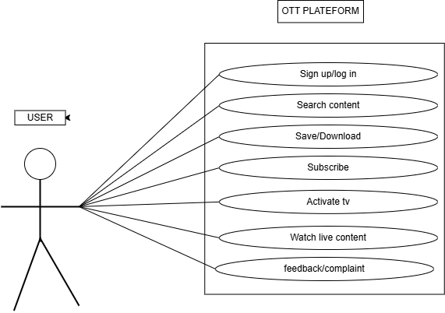

21. Draw usecase on E-commerce application.

A.

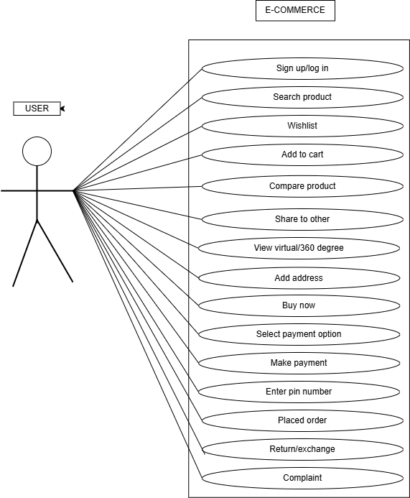

22. Draw usecase on Online shopping product using payment gateway.

A.

